PRACTICAL:1

Read a text file line by line and display each word separated by a #.

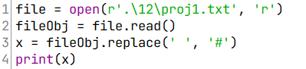

OUTPUT:



PRACTICAL:2

Read a text file and display the number of vowels/consonants/uppercase/lowercase characters in the file.

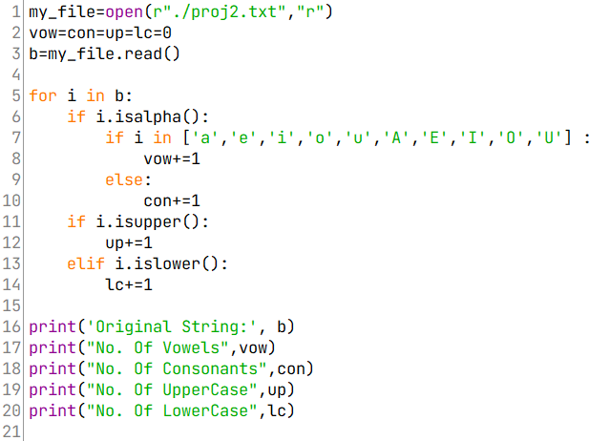

OUTPUT:

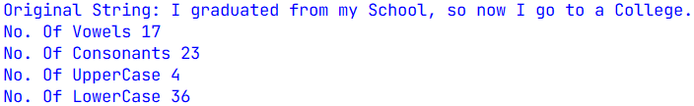

PRACTICAL:3

Remove all the lines that contain the character 'a' in a file

and write it to another file.

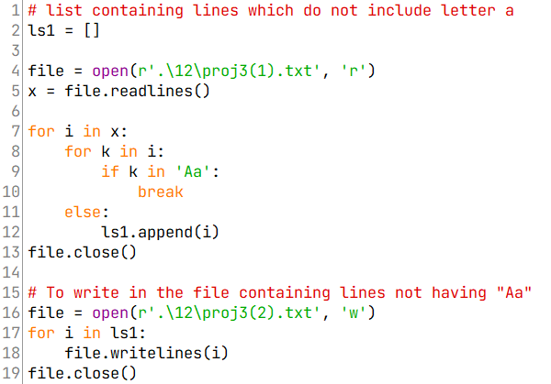

P.T.O

OUTPUT:

ORIGINAL FILE:

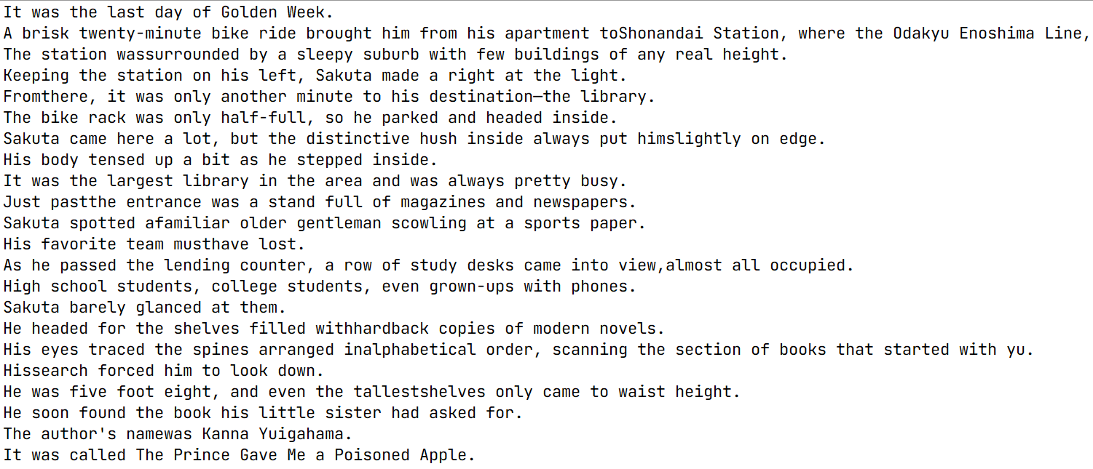

OUTPUT FILE (without Aa):



P.T.O

PRACTICAL:4

Create a binary file with name and roll number. Search for a given roll number and display the name, if not found display appropriate message.

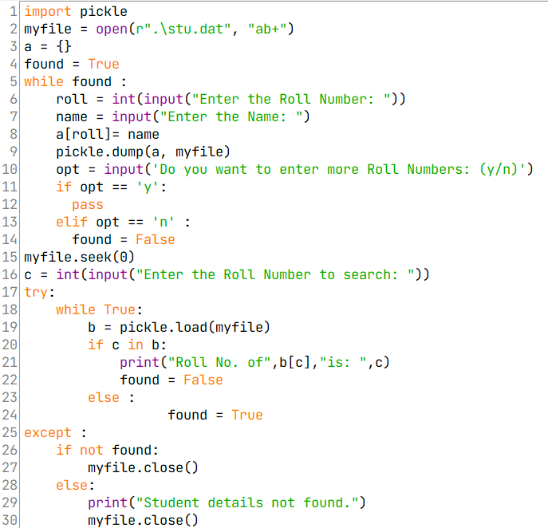

OUTPUT:

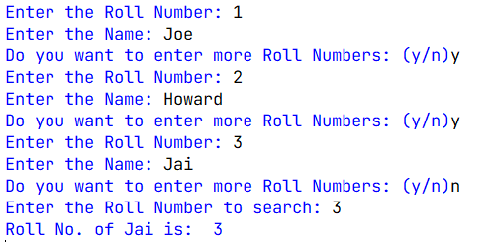

PRACTICAL:5

Create a binary file with roll number, name and marks. Input a roll number and update the marks.

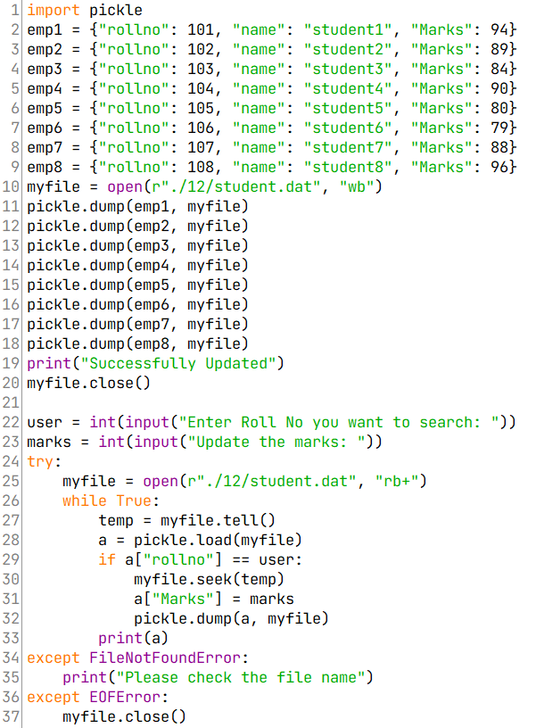

OUTPUT:

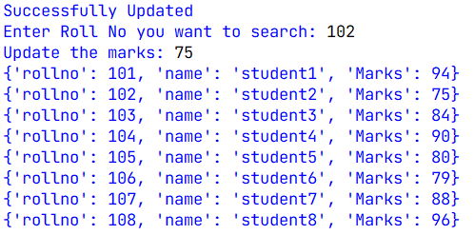

PRACTICAL:6

Write a random number generator that generates random numbers between 1 and 6 (simulates a dice).

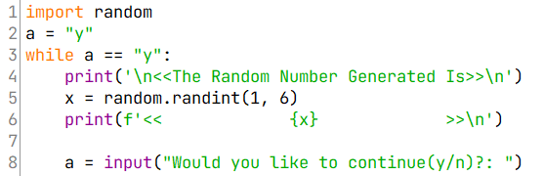

OUTPUT:

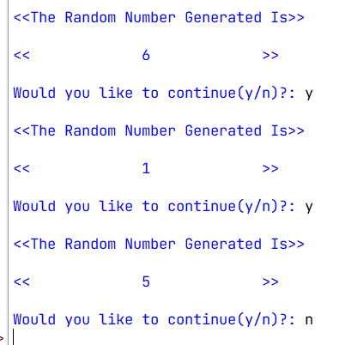

PRACTICAL:7

Write a Python program to implement a stack using list.

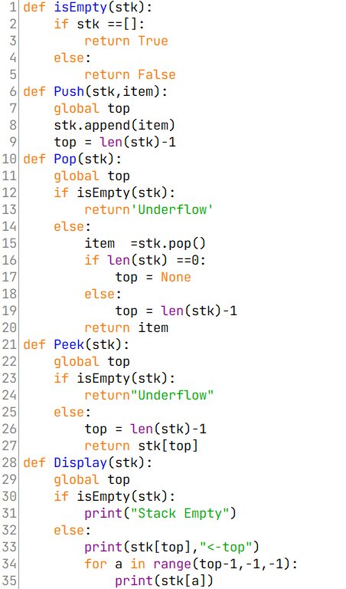

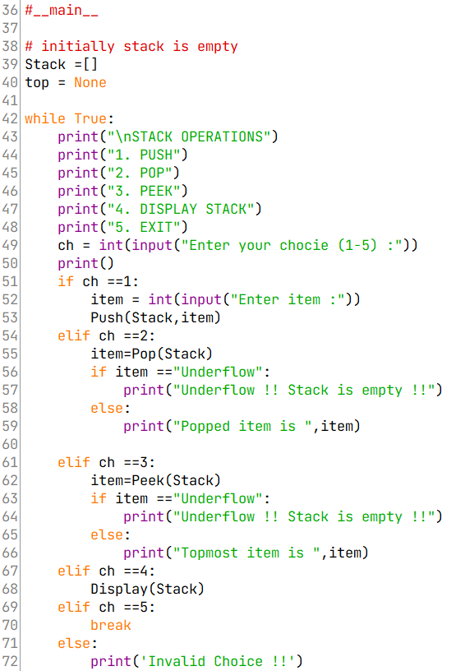

P.T.O

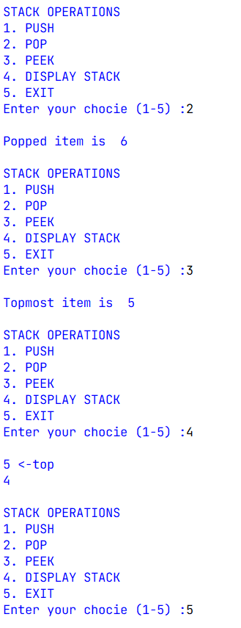OUTPUT:

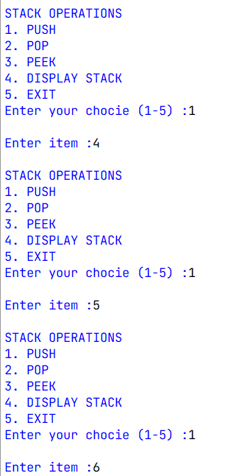

PRACTICAL:8

Create a CSV file by entering user-id and password,

read and search the password for given user id.

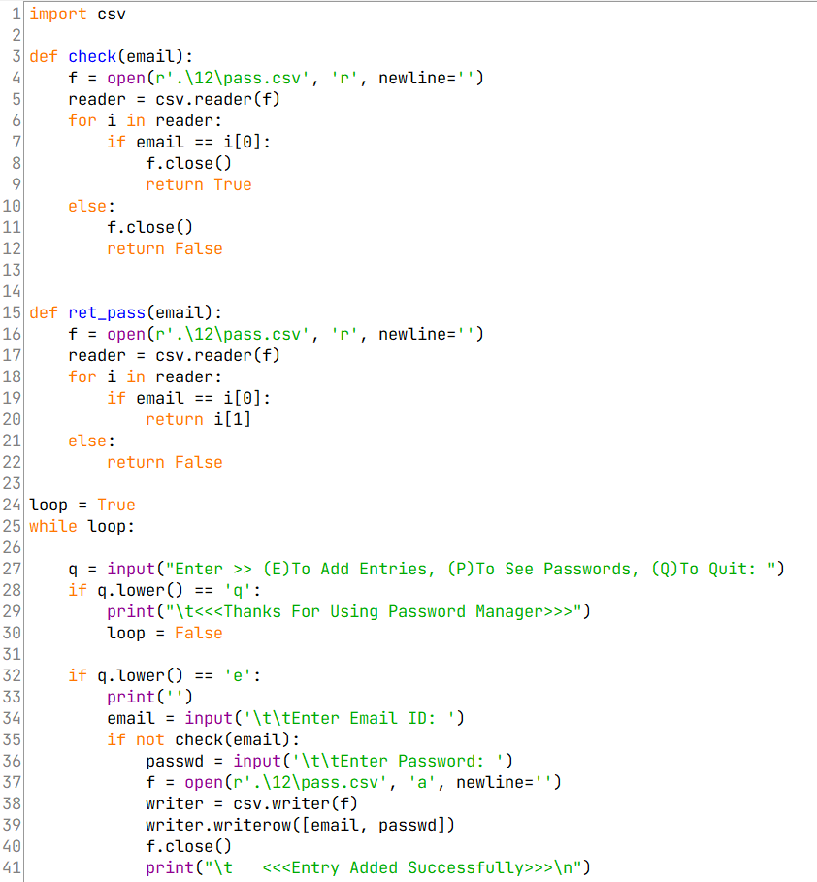

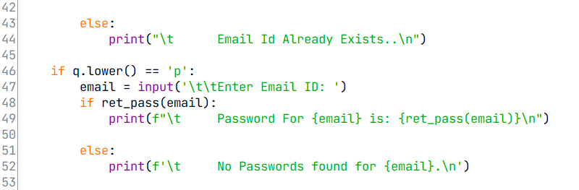

OUTPUT:

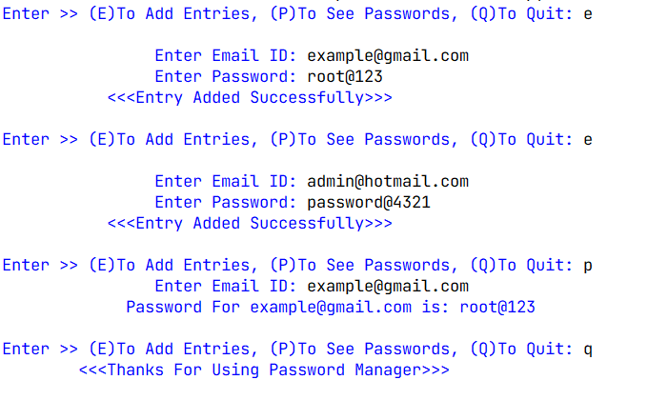

PRACTICAL:9

INIT TABLE:

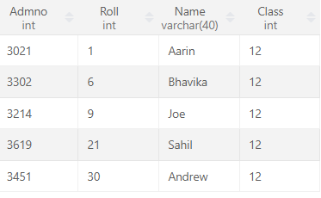

ALTER table to add new attributes / modify data type / drop attribute

Query: Alter table student add Marks VARCHAR(100);

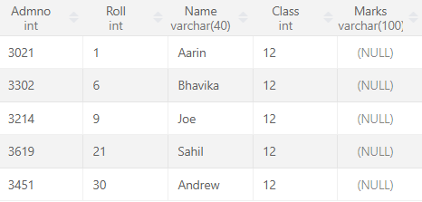

Query: Alter table student modify Marks INT(100);

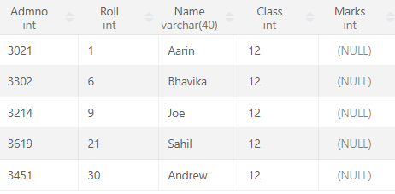

Query: Alter table student drop Class;

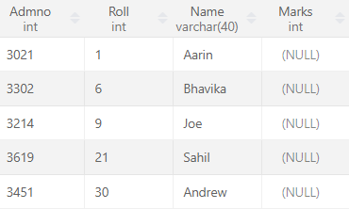

PRACTICAL:10

INIT TABLE:

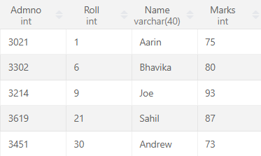

UPDATE table to modify data.

Query: UPDATE student set Admno = 3025 where Roll = 1;

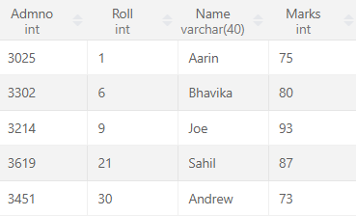

PRACTICAL:11

INIT TABLE:



ORDER By to display data in ascending / descending order.

Query: select \* from student ORDER BY Marks;

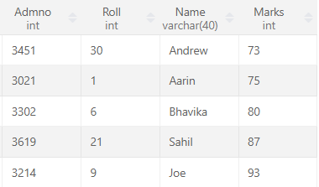

P.T.O

Query: select \* from student ORDER BY Marks desc;

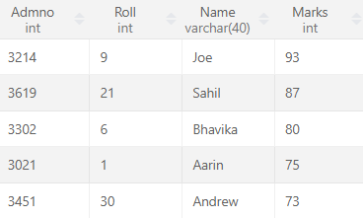

PRACTICAL:12

INIT TABLE:

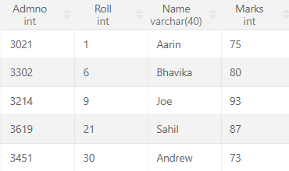

DELETE to remove tuple(s).

Query :DELETE from student where Roll = 21;

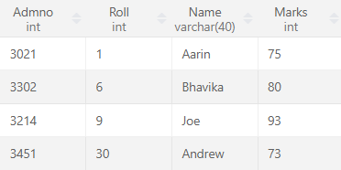

PRACTICAL:13

INIT TABLE:



GROUP BY and find the min, max, sum, count and average.

Query :select MIN(marks) from student;

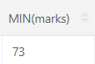

Query :select MAX(marks) from student;

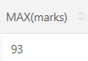

Query :select SUM(marks) from student;

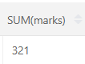

Query :select COUNT(marks) from student;

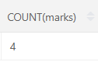

Query :select AVG(marks) from student;

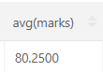

PRACTICAL:14

Integrate SQL with Python by importing suitable module.

INIT TABLE:

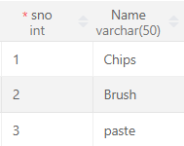

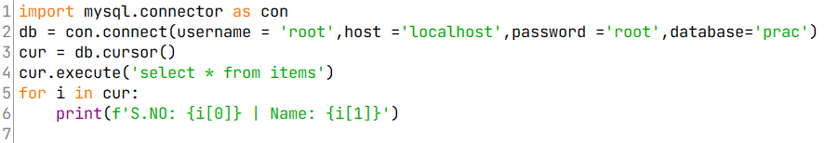

OUTPUT:

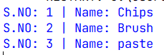

PRACTICAL:15

Find LCM and HCF of two entered numbers.

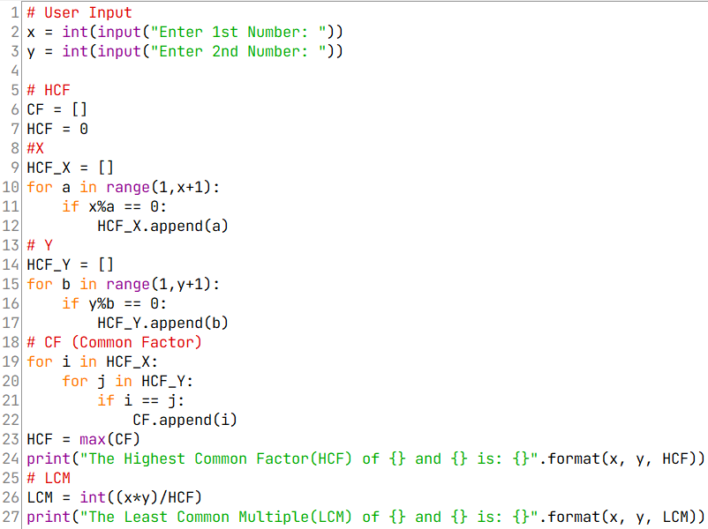

OUTPUT:

